 | 21.1.5 Editors - NLA Editor - Marker Menu
Table of content
NLA Editor - Marker Menu 1
Add Marker 1
Duplicate Marker 1
Last Operator Duplicate Time Marker 2
Frames 2
Duplicate Marker to Scene 2
Last Operator Make Links to Scene 2
Scene 2
Delete Marker 2
Bind Camera to Markers 2
Rename Marker 2
Last Operator Rename Marker 3
Name 3
Move Marker 3
Select sub menu 3
All 3
None 3
Invert 3
Before Current Frame 3
After Current Frame 3
Jump to Next Marker 3
Jump to Previous Marker 3

NLA Editor - Marker Menu

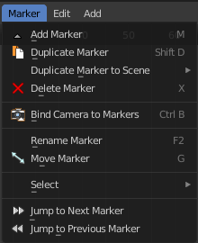
Markers are visual landmarks. They can mark a start of a specific animation sequence, the end of a camera movement, and so on.

When you add one then a marker area appears at the bottom of the timeline.

Markers can be pulled around by clicking at them and dragging them left or right. The active marker is yellow.

By holding down shift you can select more than one marker.

Add Marker
Adds a marker at the current frame position

Duplicate Marker
Duplicates the selected marker(s). The duplicate(s) sticks at the mouse until you click to give it the target destination.

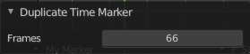
Last Operator Duplicate Time Marker

Frames
The target frame to position the duplicated marker.

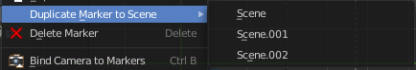
Duplicate Marker to Scene
Duplicate markers to other scenes. A blend file can contain more than one scene. See Scene Properties in the Properties editor.
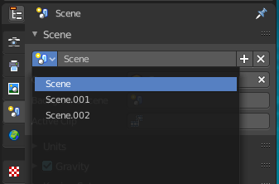

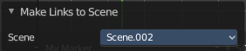
Last Operator Make Links to Scene

Scene
The target scene to duplicate the markers.

Delete Marker
Deletes the selected marker(s).

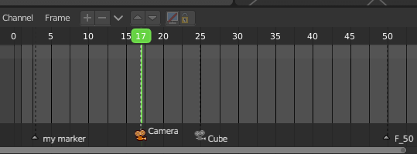
Bind Camera to Markers
Bind camera to markers turns an object into a camera object. This can be any object in the scene. Not just camera objects.
When the current frame position does not have a marker yet, then it creates a marker at the current frame position.
By binding different objects or cameras at different marker locations you can switch cameras automatically.
The marker with a bind camera attached will show a camera icon.

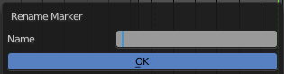
Rename Marker
A menu will open up where you can rename the active marker.
Note that for the hotkey to work you need to hover over the Marker region. In the NLA viewport F2 will call the rename menu to rename the clip instead.

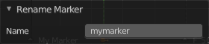
Last Operator Rename Marker

Name
Rename the active marker.

Move Marker
Hotkey only functionality! This menu item exists to show the hotkey to move the marker.

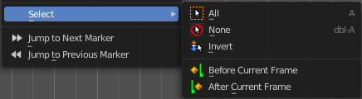
Select sub menu

All
Select all markers.

None
Deselect all markers.

Invert
Inverts the current selection

Before Current Frame
Selects the markers before the current frame.

After Current Frame
Selects the markers after the current frame.

Jump to Next Marker
Sets the frame position to the next marker.

Jump to Previous Marker
Sets the frame position to the previous marker.

